COMP – 371 Software Development And Construction
Lab Manual 07

Spring Data JPA MYSQL
GithubLink: https://github.com/Zainabtahir00/sdc

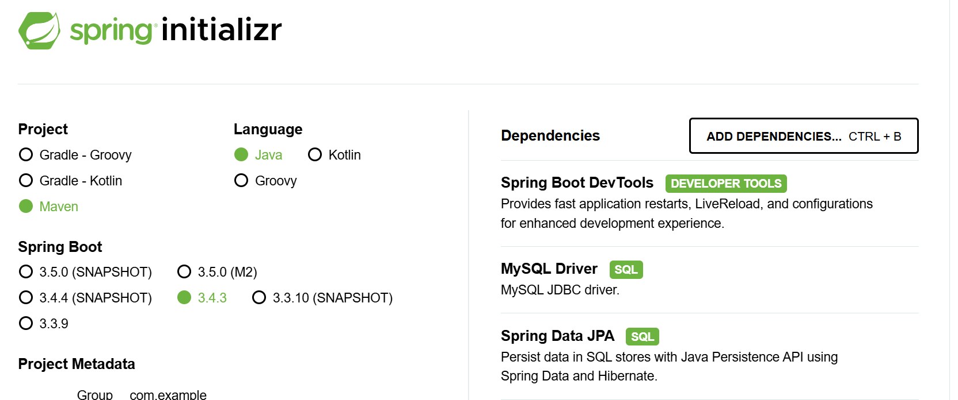

Spring Data JPA with MySQL is a technology stack that simplifies database operations in a Spring Boot application by combining the following concepts:
Spring Data JPA:
This is a Spring module that provides a high-level abstraction for data access. It allows you to define repository interfaces for your entities (your domain objects), and it automatically implements standard CRUD (Create, Read, Update, Delete) operations without the need to write boilerplate code.
JPA (Java Persistence API):
JPA is a specification for object-relational mapping (ORM). It defines how Java objects map to database tables. When you use Spring Data JPA, you usually rely on an implementation (like Hibernate) to manage these mappings and execute SQL queries behind the scenes.
Join In JPA:
In JPA (Java Persistence API), a JOIN is used to fetch related data from multiple tables based on entity relationships. It is achieved using associations like @OneToOne, @OneToMany, @ManyToOne, and @ManyToMany.

One to One Mapping:
One-to-One mapping is a type of entity relationship where one record in a table is associated with exactly one record in another table.

Student and Laptop
- Each student has exactly one laptop
- Each laptop belongs to exactly one student

This can be represented as One-to-One mapping in JPA.
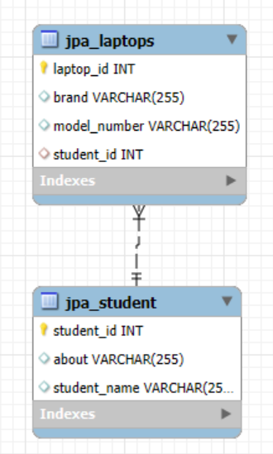

One-to-Many Mapping in JPA
One-to-Many is a relationship where one entity (parent) is associated with multiple records of another entity (child).

Example
- One Student can have many Laptops
- One Department can have many Employee

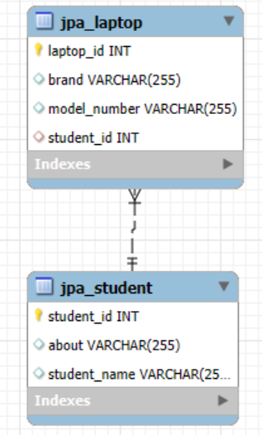

Many-to-Many Relationship Definition in JPA
A Many-to-Many relationship in JPA occurs when multiple records in one entity are associated with multiple records in another entity.

Example Use Case
- A Student can enroll in multiple Courses.
- A Course can have multiple Students.
To model this, we use the @ManyToMany annotation in JPA.
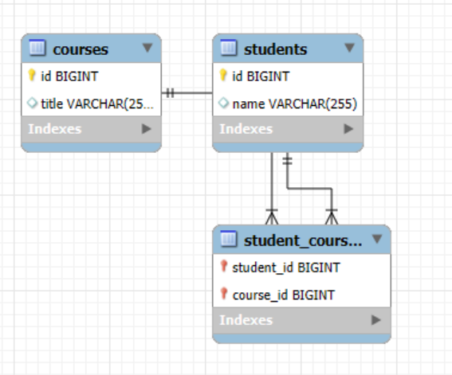

Definition of Custom SQL Query in Spring Boot
A Custom SQL Query in Spring Boot (Spring Data JPA) refers to a manually written SQL statement that retrieves, updates, inserts, or deletes data from a database instead of relying on automatically generated queries by JPA.

Why Use Custom SQL Queries?
- Complex Queries: When built-in JPA methods (findById, findAll, etc.) are not sufficient.
- Performance Optimization: Custom queries can be optimized for better database performance.
- Native SQL Usage: When you need database-specific queries (e.g., using JOIN, GROUP BY, HAVING).
- Aggregation & Custom Operations: When performing SUM, AVG, COUNT, MIN, MAX, etc.

